LOW CODE NO CODE
HEALTH AND FITNESS TRACKING SYSTEM
A health app needs to track users' fitness progress, including workout routines, calories burned, and daily steps. The system should provide insights on health trends and offer suggestions based on progress.
Project Overview:
In this project, students will build a fitness tracker where users can log workouts, track calories burned, and set goals for their health. The system will automate fitness progress tracking, offer suggestions for improvement, and generate fitness reports.
Tools and Workflow:
ChatGPT Assist with workout tracking categories and suggestions for improvement
Bubble: Build the application for logging workouts, steps, and calories
Airtable: Store workout logs, calories burned, and goal progress data
Jotform: Create forms for logging user activities and progress Make: Automate progress tracking and goal reminder notifications n8n: Build workflows to generate health progress reports and send notifications
Nanobanana Gemini Generate visual representations of fitness progress for reports

System Architecture
The Health and Fitness Tracking System follows a multi-tier architecture that integrates various tools and platforms to deliver a comprehensive fitness tracking solution:

1. Frontend Layer User Interface)
Bubble: Provides the main application interface where users interact with the system
Jotform: Handles data entry forms for logging workouts, meals, and daily activities
Users can view their dashboard, log activities, set goals, and monitor progress through intuitive interfaces

2. Data Storage Layer
Airtable: Serves as the central database storing:
User profiles and authentication data
Workout logs (type, duration, intensity)
Calorie tracking (burned and consumed)
Daily step counts and activity metrics
Goal definitions and progress tracking
Historical data for trend analysis

3. Intelligence & Processing Layer
ChatGPT: Provides AI-powered features including:
Workout categorization and tagging
Personalized fitness recommendations
Natural language processing for user queries
Suggestion generation based on user progress Nanobanana Gemini : Generates visual analytics:
Progress charts and graphs
Trend visualization
Comparative analysis displays
Health metric dashboards

4. Automation & Integration Layer
Make: Orchestrates automated workflows:
Progress tracking calculations
Goal milestone detection
Reminder notifications for workouts
Data synchronization between platforms n8n: Manages complex workflows:
Report generation automation
Scheduled health summary notifications
Data aggregation and processing
Email/push notification delivery

5. Documentation & Planning Layer
Notion AI: Organizes and maintains:
Project documentation
Data structure definitions
Workout type taxonomies
System specifications and requirements
Implementation Details:

Airtable Database
We created three interconnected tables—Users, Workouts, and Progress Logs—to serve as the central database for the fitness tracking platform. Each table includes specific fields with appropriate data types, relationships, and validation rules to ensure data integrity and seamless integration with other tools.
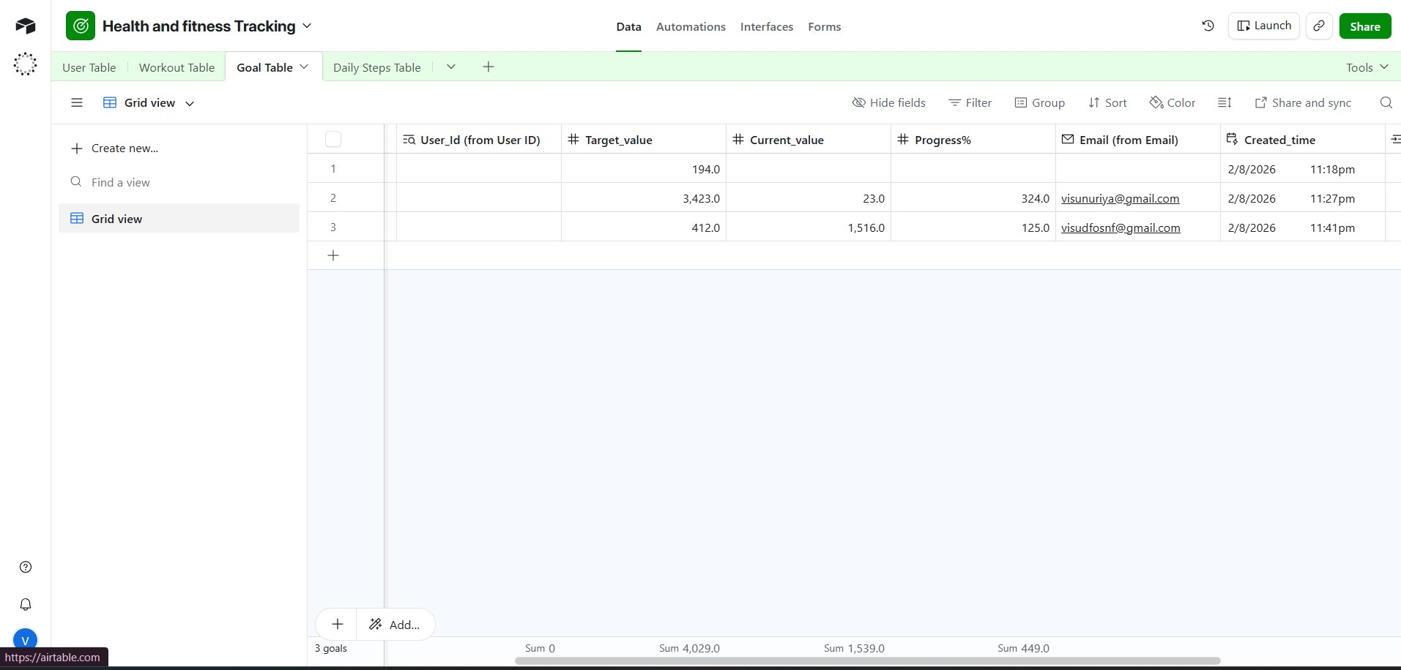

JotForm Task Creation Form
Designed a user-friendly task creation form with all essential fields including Daily steps
name, caloires,target,Duration and workout category. The form features conditional logic, input validation, and a clean interface that ensures data quality before submission to Airtable.
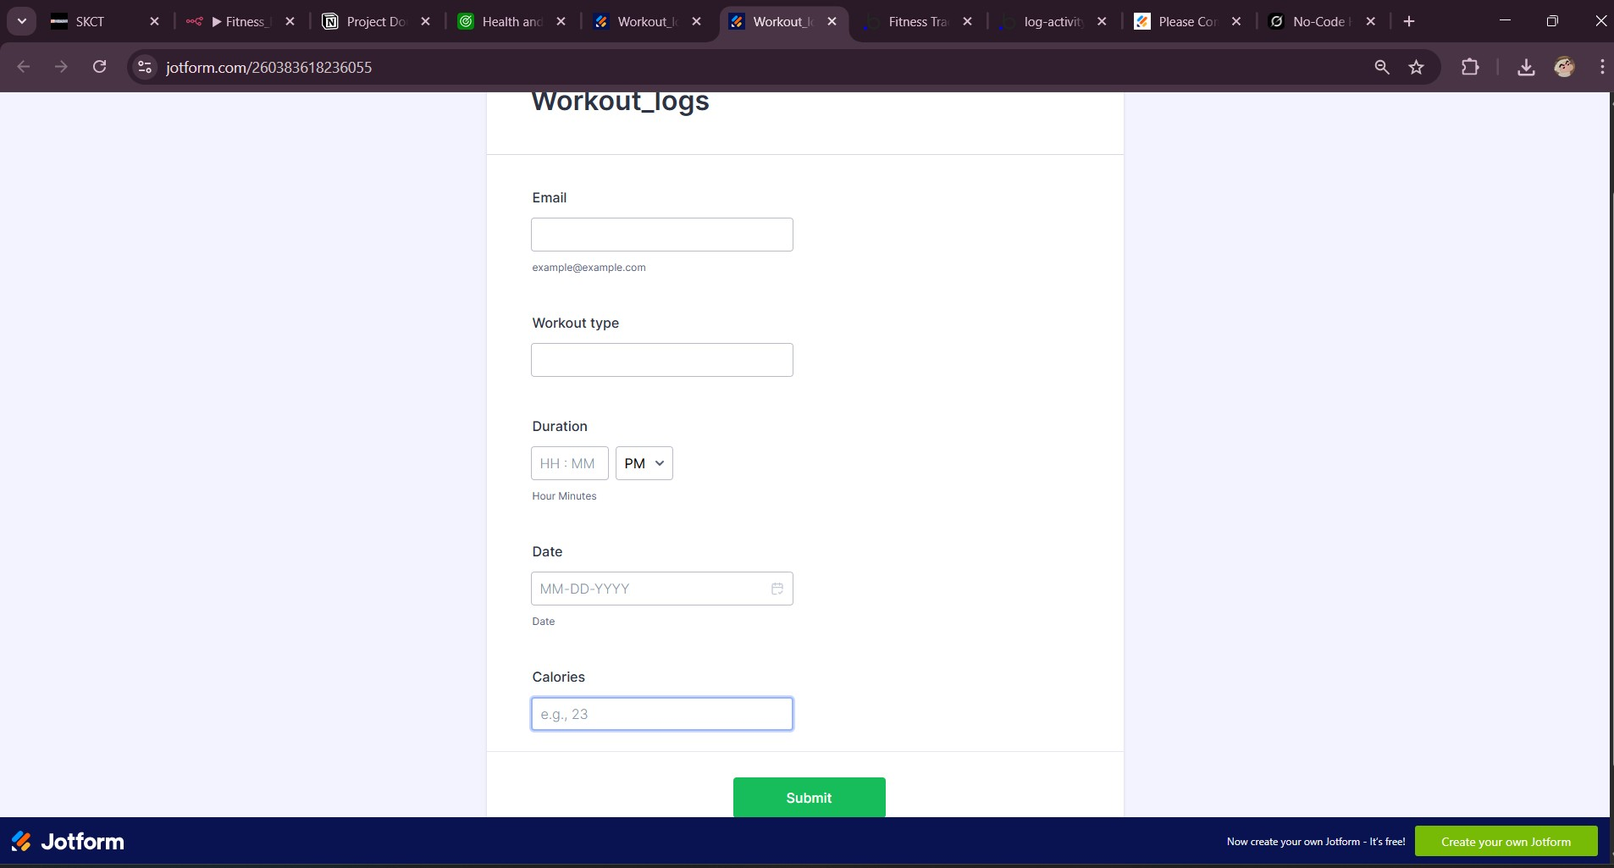

Jotform and Airtable Intergration
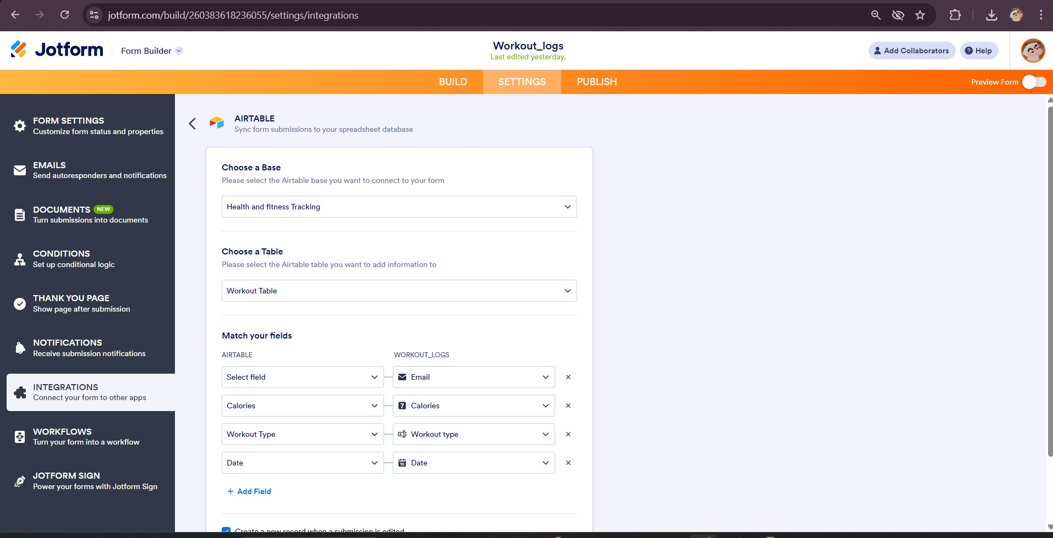

Make Automation Workflow
Built an automated workflow that runs daily to check for tasks due within 24 hours and sends email reminders to assigned team members. The scenario includes scheduled triggers, Airtable search modules with date filtering, iterators for multiple tasks, and email modules with personalized message templates
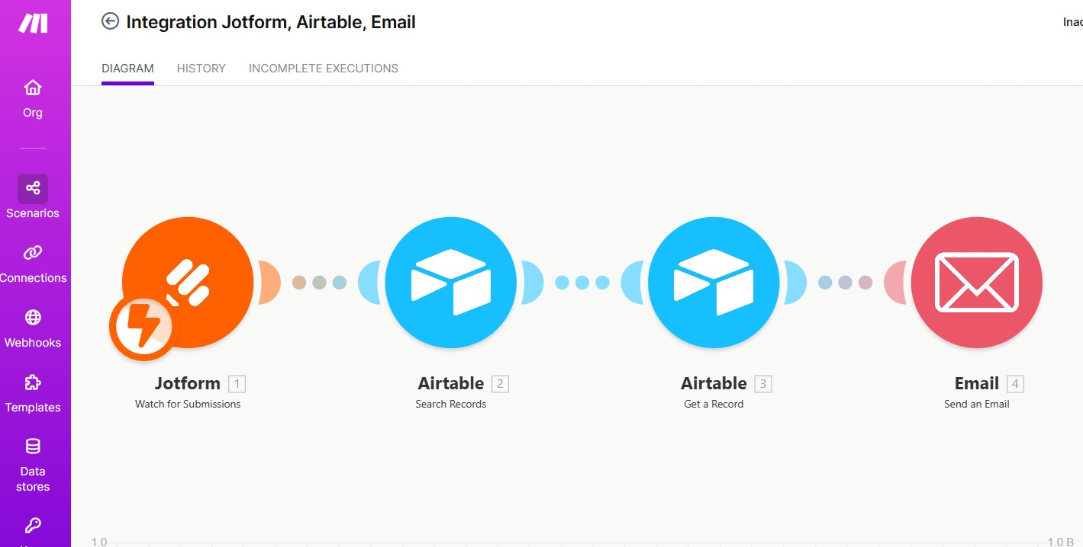
n8n Workflow:
The health progress reporting and notification system is built using Make.com and n8n to automate personalized user engagement. Weekly progress reports aggregate data from Airtable (workout logs, steps, calories, and goal progress) over the past seven days, calculate totals and trends, and enrich the summary with encouraging, actionable suggestions generated via ChatGPT. These reports are formatted into clean HTML emails and sent automatically every Monday morning, optionally including visual progress charts created with Google Gemini.
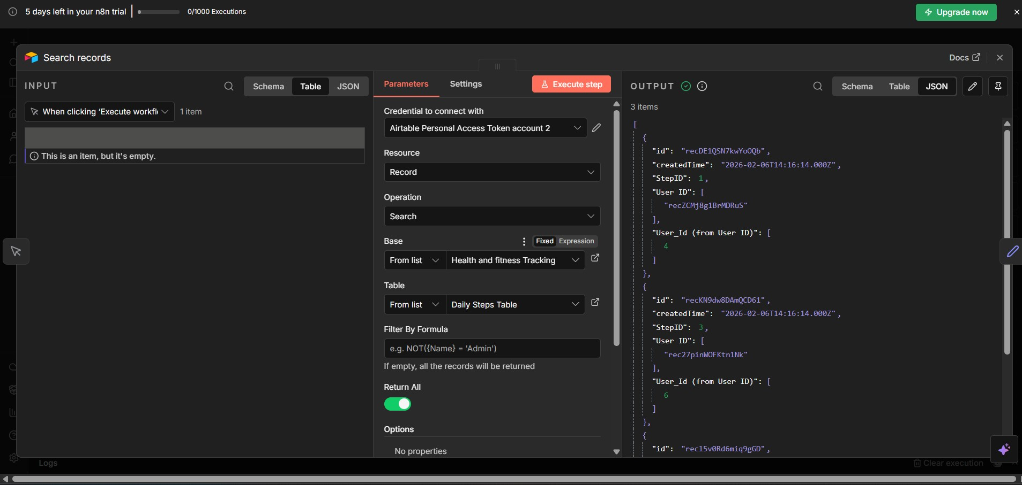

Landbot Chatbot Interface
Task Management Platform-Low Code & No Code Application
Developed a conversational chatbot with multiple flows enabling users to check their task status, through natural language queries. The bot integrates with Airtable via API to fetch real-time data and presents information in a user-friendly conversational format
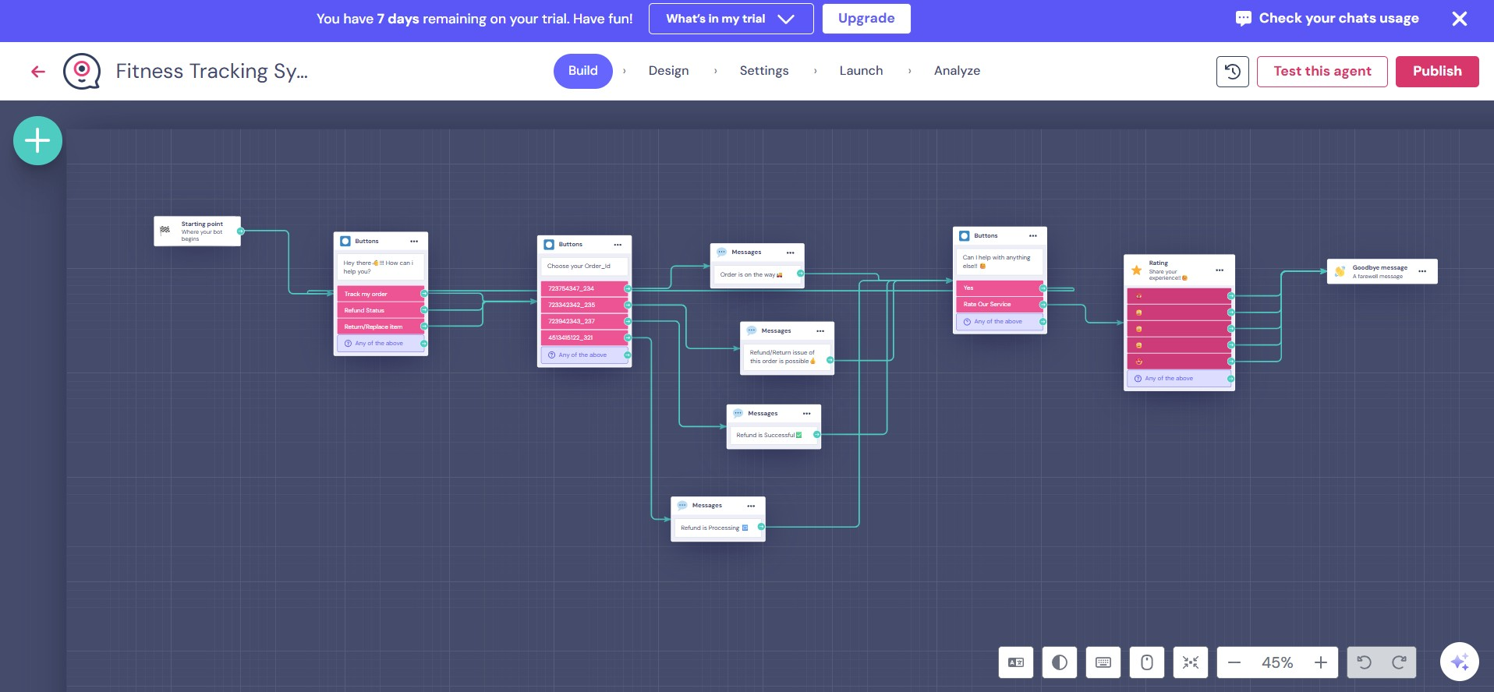

Web Interface
Created a responsive web Pagethat serves as the central hub for the task management platform, embedding both the JotForm task creation form and Landbot chatbot widget. The interface features a clean, professional design with intuitive navigation and seamless integration of all platform components
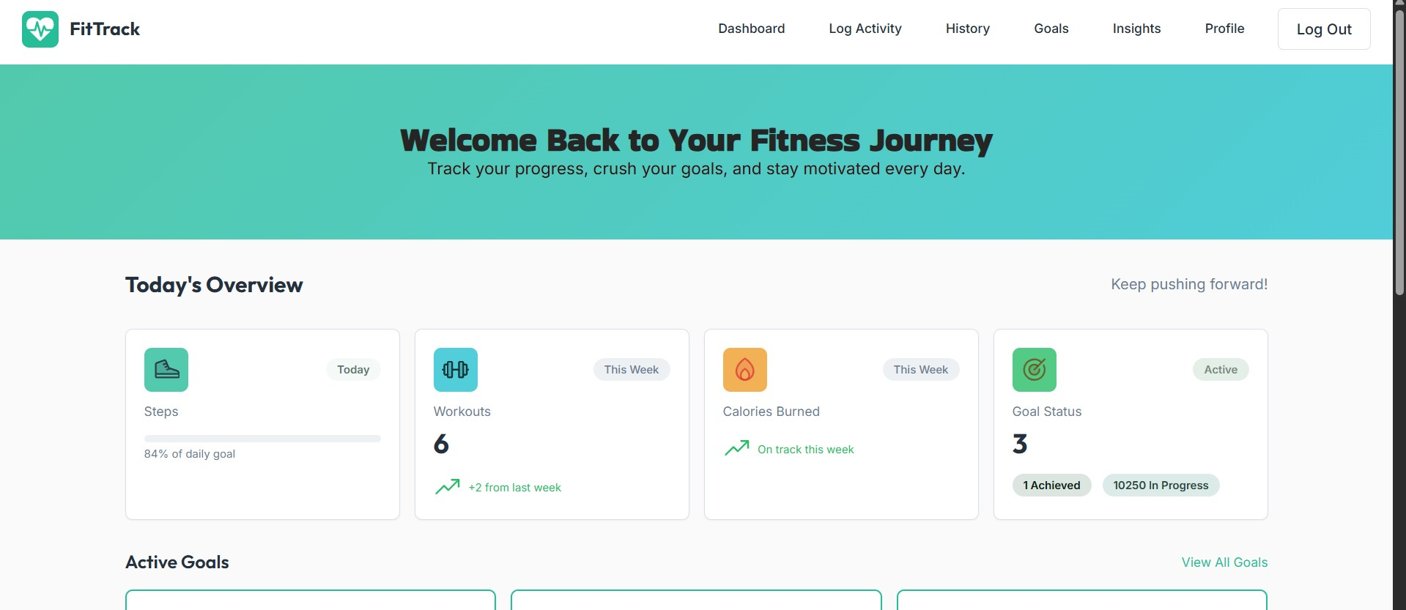
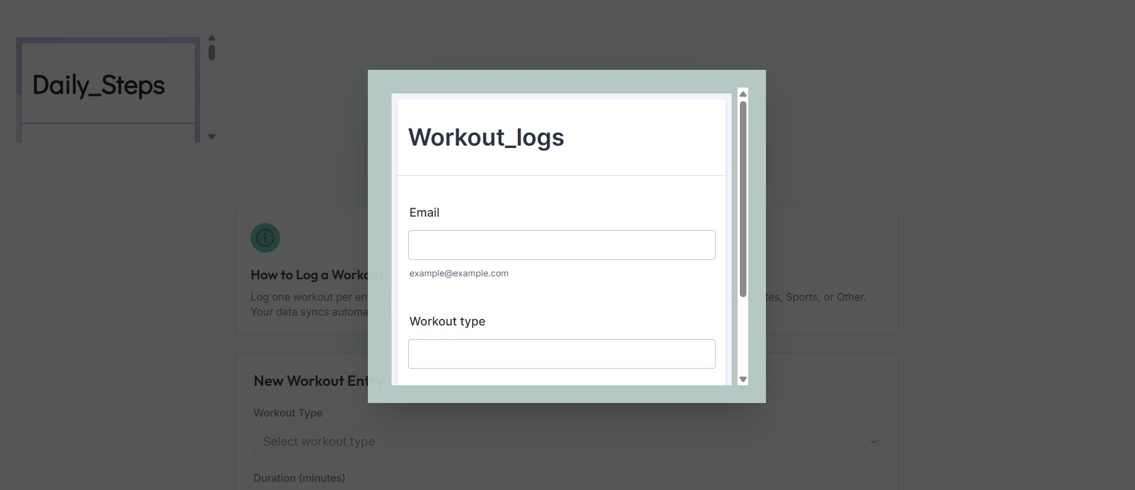
Data Flow:
User inputs data via Bubble interface or Jotform
Data is stored in Airtable database
Make/n8n workflows trigger automated processing
ChatGPT analyzes data and generates insights
Nanobanana creates visual representations
Results are displayed back to user via Bubble
Automated notifications sent through Make/n8n
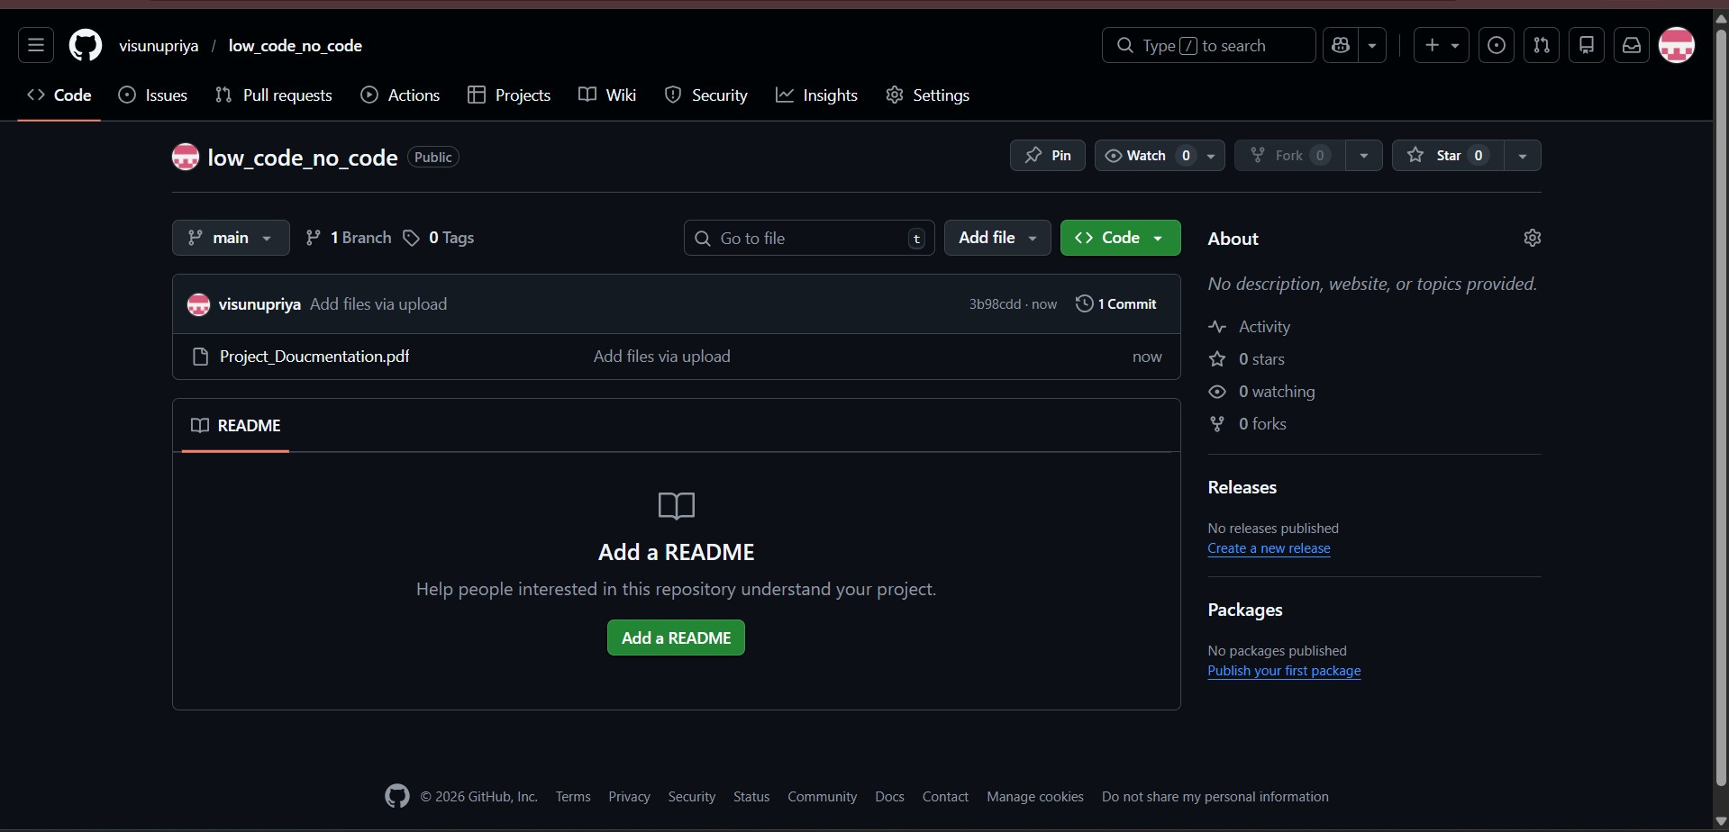

Conclusion
The Health and Fitness Tracking System represents a comprehensive solution for individuals seeking to monitor and improve their physical well-being. By integrating multiple specialized tools—Bubble for application development, Airtable for data management, ChatGPT for intelligent insights, and automation platforms like Make and n8n—the system delivers a seamless user experience that combines manual logging with automated tracking and personalized recommendations.
The modular architecture ensures scalability and maintainability, allowing for future enhancements such as integration with wearable devices, social features for community support, or advanced analytics powered by machine learning. The automation layer reduces manual effort while ensuring users stay engaged with timely reminders and progress updates.
This project demonstrates the power of no-code and low-code platforms combined with AI capabilities to create sophisticated health tracking applications. Students will gain hands-on experience in system design, API integration, workflow automation, and data visualization—skills that are highly relevant in today's technology landscape.
Ultimately, this fitness tracking system empowers users to take control of their health journey by providing actionable insights, maintaining accountability through goal tracking, and offering personalized guidance for continuous improvement. The combination of automated data processing and intelligent recommendations creates a sustainable approach to fitness management that adapts to each user's unique needs and progress.

